**Annual Autumn Fair**

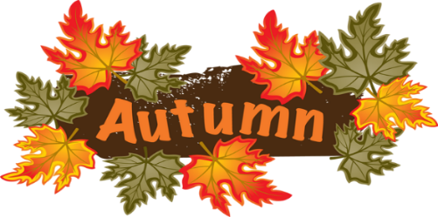**8am Saturday 11 March 2023**

**Bowral Uniting Church**

**(opposite Coles supermarket)**

**All your favourite stalls:**

**Books, DVDs --- a new supply**

**Plants**

**Home Baked Goodies**

**Jams & Marmalades**

**Craft**

**All your favourite food:**

**All day BBQ from 8.00am**

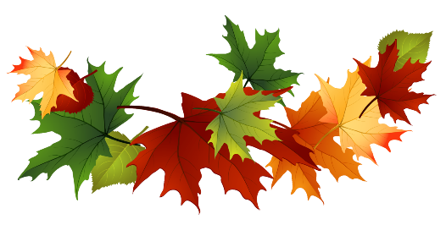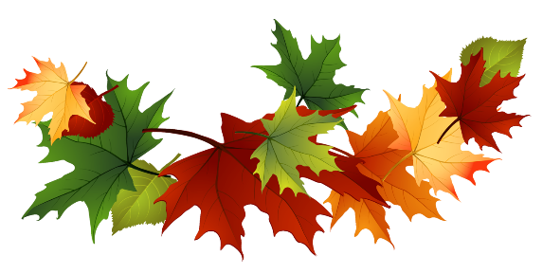**All day Devonshire Tea/Coffee**