**

***Iconic ‘Fathers’***

***Tour 3: July 8-16***

**Natalie Chee, violin | Julian Smiles, cello | Kathryn Selby, piano**

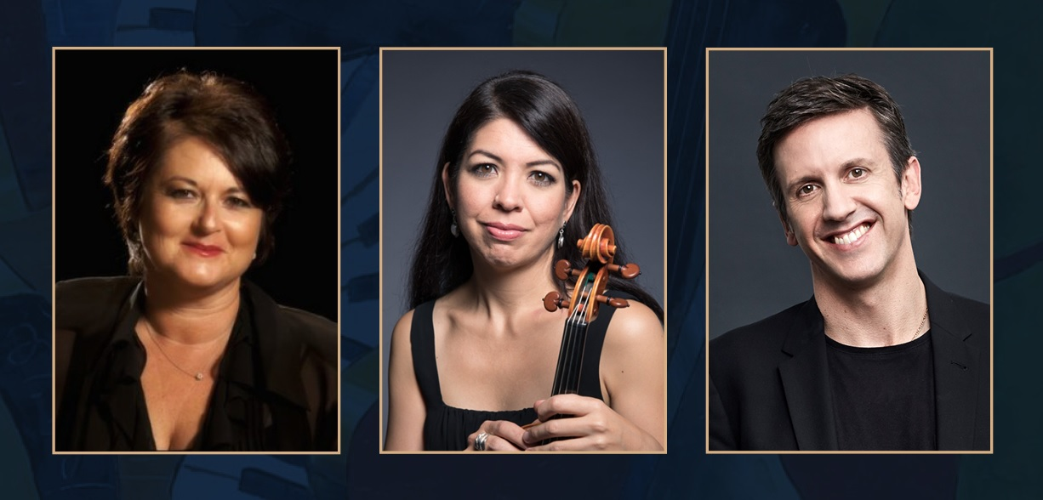

**Joseph Haydn**

Piano Trio in D Major Hob XV:24

**Arnold Schoenberg**

*Verklärte Nacht* for Piano Trio, Op. 4

(Transcription by Eduard Steuermann)

**Antonín Dvořák**

Piano Trio No. 4 in E minor, Op. 90 “Dumky”

l

**ICONIC ‘FATHERS’**

**‘Papa’ Haydn, Transfigured Night and the ‘Dumky’**

Selby & Friends, hailed by *Limelight* magazine as “chamber music at its best”, tours to major metro and regional locations with its newest program, *Iconic ‘Fathers’*, from July 8th to 16th. This third Selby & Friends tour of 2023 features special guest artists and old friends violinist Natalie Chee and cellist Julian Smiles in performance with Artistic Director and pianist Kathryn Selby AM. Stops on this concert tour include Sydney, Melbourne, Canberra, Adelaide, the NSW Southern Highlands and Turramurra on Sydney’s Upper North Shore.

Named for iconic composers– Joseph Haydn, Arnold Schoenberg and Antonin Dvořák – the program presents three undeniable trailblazers whose artistic influence turned the norms of earlier classical music on their head. Inhabiting very different eras spanning the 18th to the 20th centuries, and the very diverse societies of Austria, England, Germany, Bohemia and America, these composers paved the way for the music that came after them.

The musicians performing on the *Iconic ‘Fathers’* tour have been regular and favourite Selby & Friends guest artists over the past 10 years. Sydney-born Natalie Chee has an international career as an extraordinary chamber musician, solo violinist and concertmaster. She has been a member of Camerata Bern and Camerata, and co-founded the ensembles ‘Tiramisu’ and the Mozart String Quartet. She is Concertmaster of the Radio Symphony Orchestra in Stuttgart and the Gürzenich Orchestra in Cologne, and a regular guest Concertmaster of the Australian World Orchestra and the BBC Symphony Orchestra. Cellist Julian Smiles is well-known throughout Australia and beyond as the critically acclaimed cellist of the Australia Ensemble and founding member of the prestigious award-winning Goldner String Quartet.

Artistic Director and pianist Kathryn Selby looks forward to welcoming these special friends back to perform piano trios by three pioneering composers in Selby & Friends’ 17th season:

“To work with Natalie and Julian again on such a powerful and influential program is a true joy and one of the absolute high points of the current season. Both my guests are old friends and wonderful colleagues and the program reflects our love and respect for not only the chamber music genre but the indelible influence of three masterful composers and their vision and genius.”

**Iconic ‘Fathers’ - TOUR DATES and direct links below:**

[Saturday, 8 July: Bowral, NSW Southern Highlands @ 4:00pm - St Jude’s Church](https://www.selbyandfriends.com.au/tour/iconic-fathers/)

[Sunday, 9 July: Turramurra @ 2:15pm - Turramurra Uniting Church](https://www.selbyandfriends.com.au/tour/iconic-fathers/)

[Monday, 10 July: Sydney @ 7:00pm - City Recital Hall](https://www.cityrecitalhall.com/whats-on/events/iconic-fathers/)

[Wednesday, 12 July: Melbourne @ 2:00pm - Primrose Potter Salon, Melbourne Recital Centre](https://www.melbournerecital.com.au/events/2023/iconic-fathers/)

[Wednesday, 12 July: Melbourne @ 7:00pm - Primrose Potter Salon, Melbourne Recital Centre](https://www.melbournerecital.com.au/events/2023/iconic-fathers/)

[Thursday, 13 July: Canberra @ 7:00pm - NGA James Fairfax Theatre](https://www.selbyandfriends.com.au/tour/iconic-fathers/)

[Sunday, 16 July: Adelaide @ 2:15pm - Elder Hall, University of Adelaide](https://www.selbyandfriends.com.au/tour/iconic-fathers/)

**Information and bookings at** **selbyandfriends.com.au** **| 1300 511 099 or 0473 126 172**