***Vivace Berrima!* presents**

***Lord Abingdon’s Flute: The Haydn London Trios, Weber & Farrenc trios***

**Artists:**

**Sally Walker (flute)**

**Minah Choe (cello)**

**Daniel Herscovitch (piano)**

**Sunday 10 September 2023 at 2:30pm**

**Berrima Village Hall**

**Located in the main street of Historic Berrima, a short walk down from**

**The Bakehouse Motel on same side & car park out the front.**

**Adjacent to Holy Trinity Anglican Church, Southern Highlands of NSW**

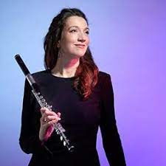

**To purchase tickets to “Lord Abingdon’s Flute: The Haydn London Trios, Weber & Farrenc trios**,contact Lyndall on 0408 839 687 to discuss paying cash at door OR Deposit $35 per person full price  / $20 **student only** concession, to:

**Westpac Bowral**

**BSB 032 716 Account No. 476748**

**Account Name: Vivace Berrima**

**Please Reference: Your Surname/Mobile**

***Send confirmation of booking purchase to:***

**lyndall1906@ bigpond.com or mobile 0408 839 687.**

***\*\*\*If booking less than one week prior to concert, check availability first!\*\*\****

**Reception afterwards including glass of wine**

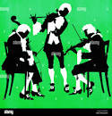

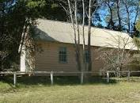

Did you know that there is a public park in Greenwich Village, New York City known as Abingdon Square Park named after Lord Abingdon (1740-1799), flautist and acquaintance of Austrian composer Joseph Haydn?